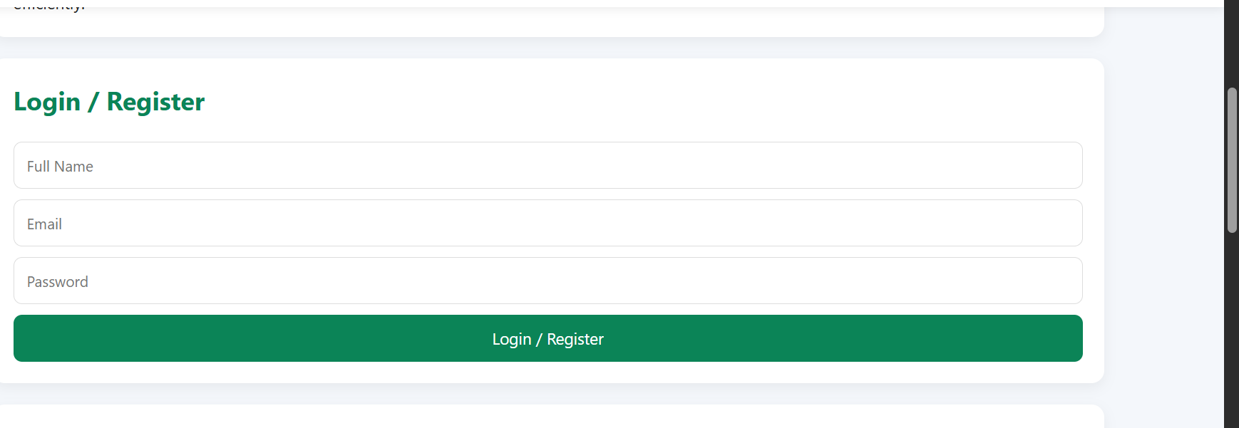
Figure 5. 1: Login Screen (Resident /Requester)

Admin Login Screen.


Figure 5. 2: User Registration Screen

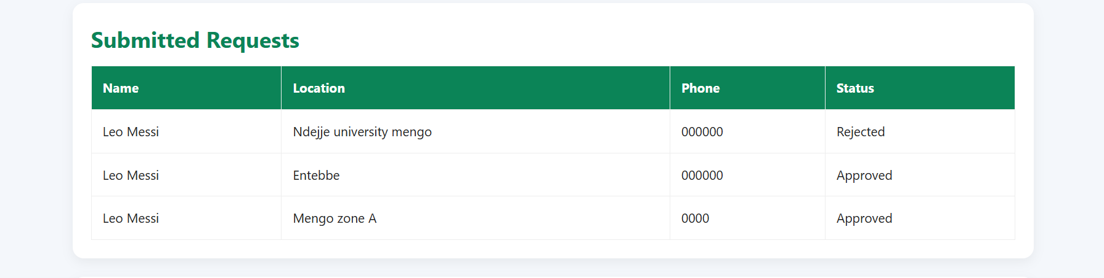
Figure 5. 3: Resident Dashboard

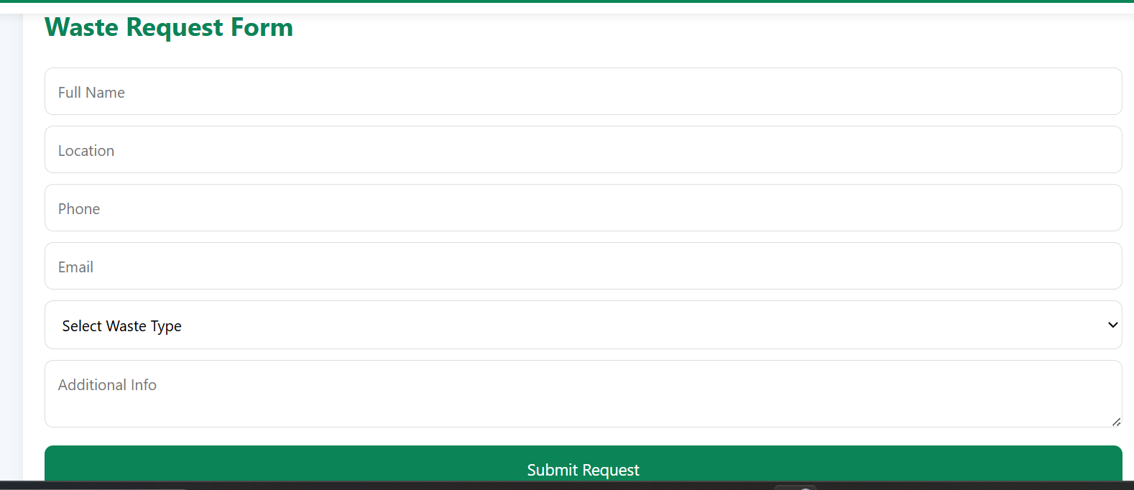
Figure 5. 4: Waste Collection Request Form

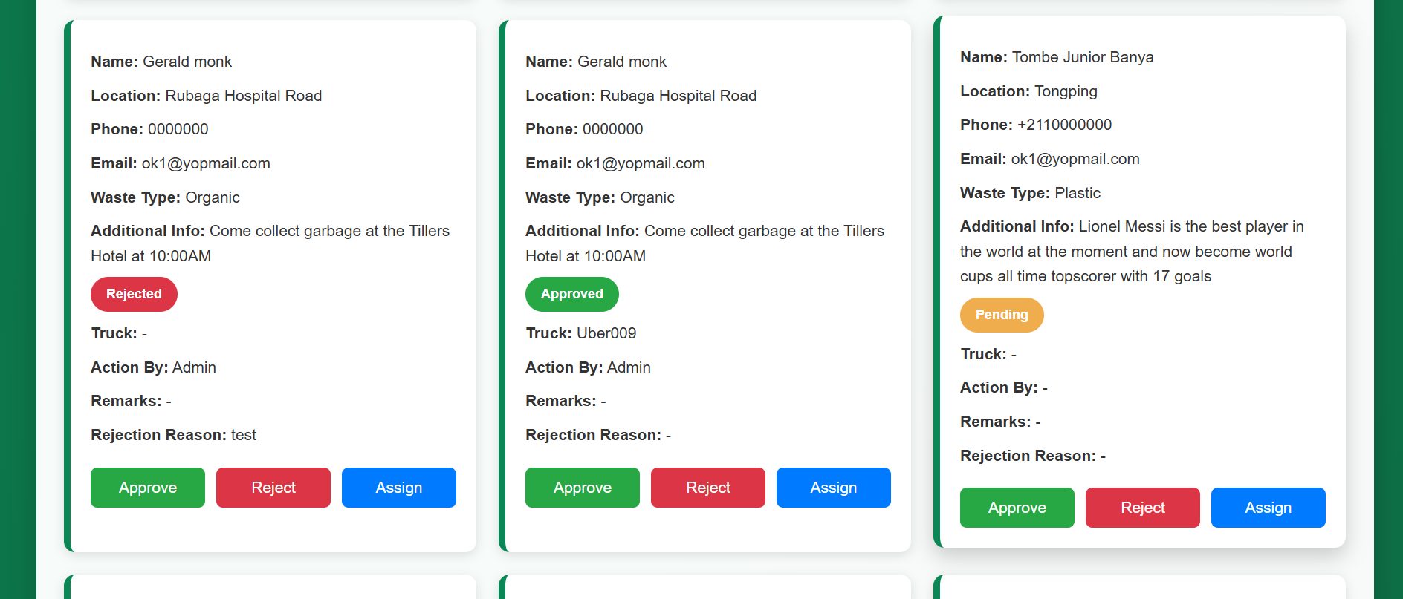
Figure 5. 6: Request Details

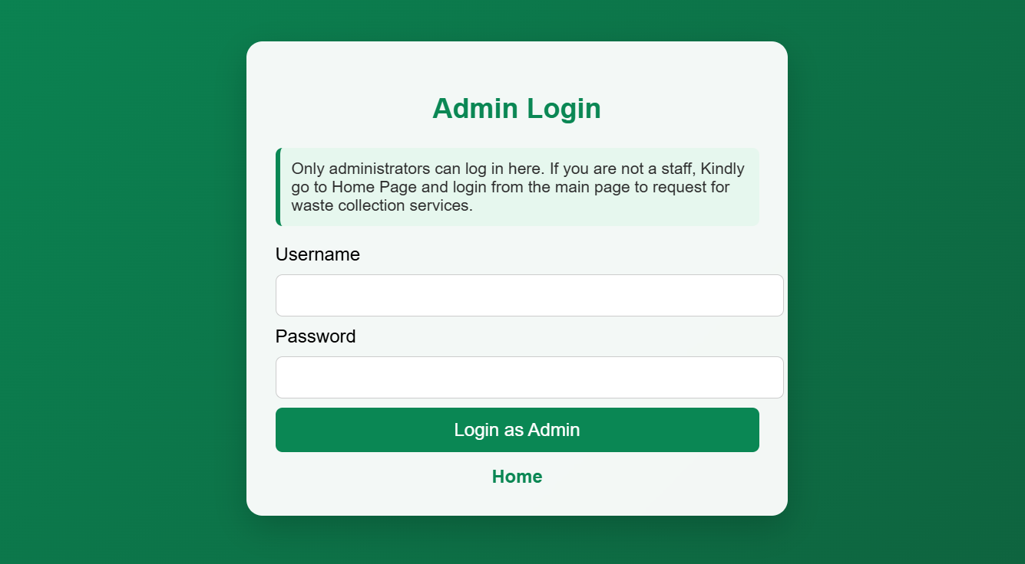
Figure 5. 8: Login Screen
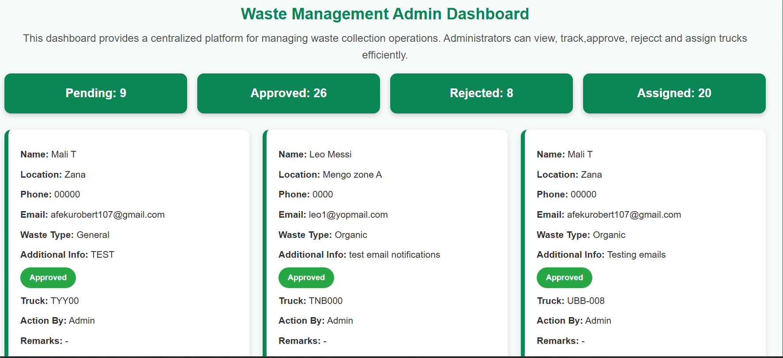
Figure 5. 9: Administrative Dashboard

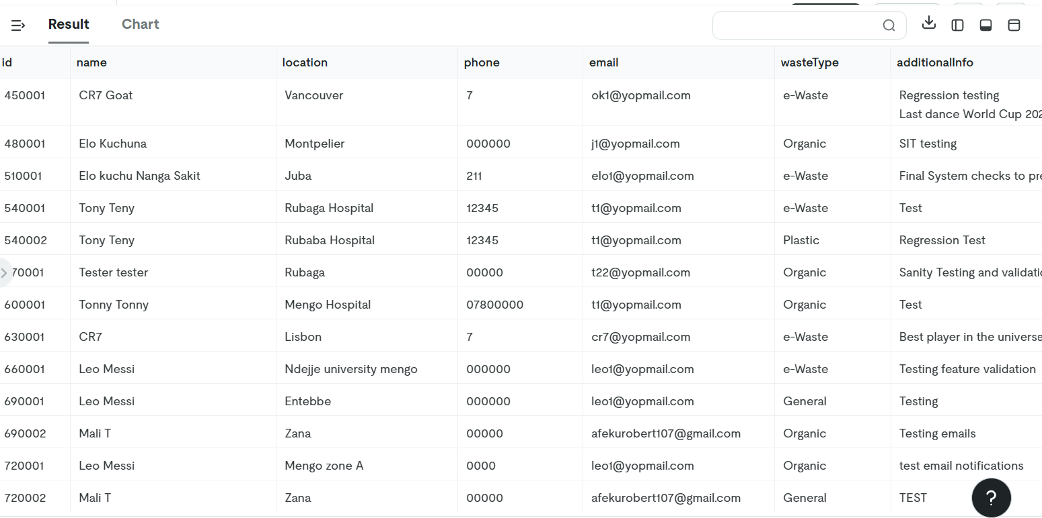
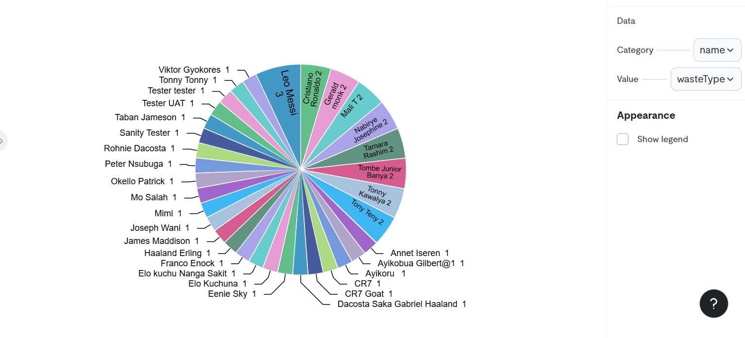Figure 5. 11: Reports Interface

